Electronic Record Keeping Information Form
The Walker High School Sports Medicine team uses an Electronic Record Keeping system called Healthy Roster. This system is used to keep track of injuries and updates to your athletes. Please use the QR code below to fill out your athlete’s information. Parents will have access to updates and injuries through the Healthy Roster App once your athlete has been uploaded. This is also where you will be able to find a copy of their physical form and message the Athletic Trainer with any questions you may have regarding the health of your athlete throughout the school year.

Step 1: Scan the QR code

Step 2: Fill out your athlete’s information

Step 3: Look for an invite in the email that was provided in the information form to download the Healthy Roster App (this will be sent once the Sports Medicine Team uploads your athlete’s info)



Step-By-Step Guide to creating an account: App (look for an email from Healthy Roster)
- Once you've downloaded the app select: Sign Up

- Input the access code from your invitation into the Access Code text box exactly as it appears on your invitation
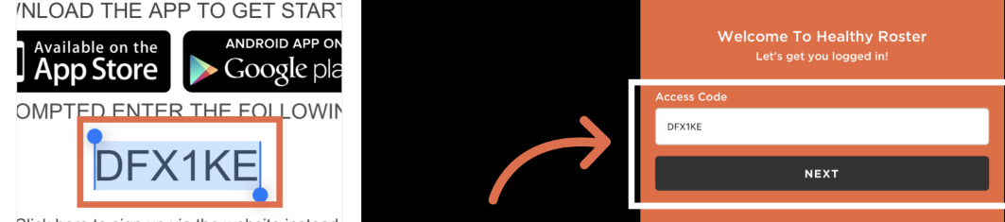

- Confirm your email by typing in the same email that your invitation was delivered to. Select Next.


- Input your account information and select Next
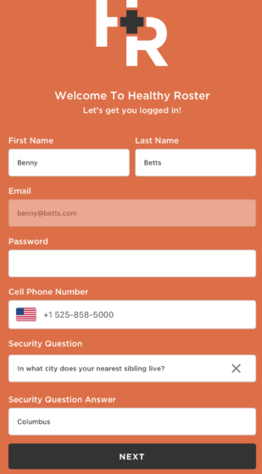
- Review our privacy policy and terms of use, select Accept terms
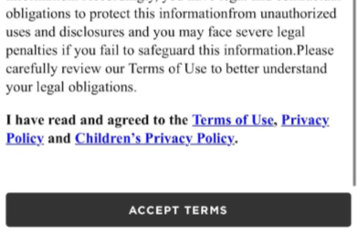

Step-By-Step Guide to creating an account: Web
- Open your invitation from your email
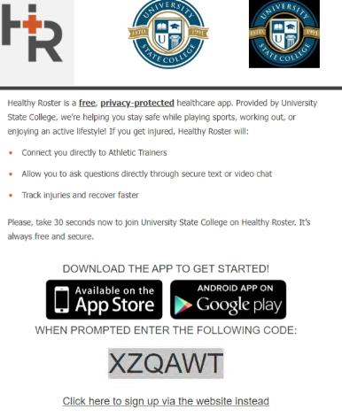
- Select Click here to sign up via the website instead

- Input your access code. This code should match the code exactly on your invitation.


- select Next

- Select I Need To Create A New Account
- Input your information and select Register
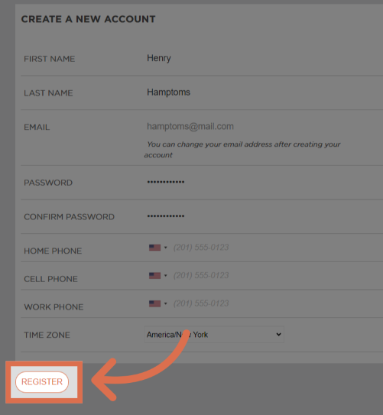

- Review the privacy policy/terms of use. Check the box to attest to the information.
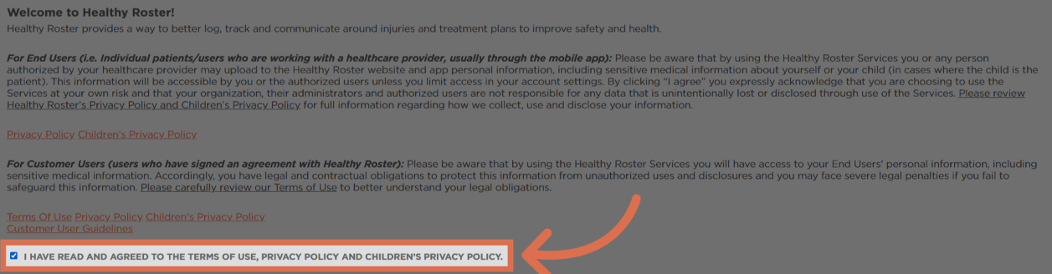
- Select Next

- Select security questions and input answers for each. Select Save answers.
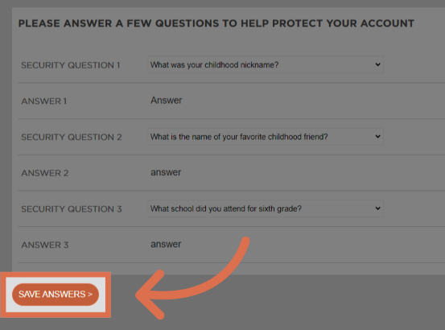


- Select Continue To Dashboard

Step-By-Step Tutorial - Scanning a Required (Missing) Document
- Within the Healthy Roster app, go to your patient profile and click on the Documents Tab
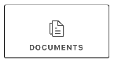
- Tap a document from the Missing Documents section that you're ready to scan and upload. (your documents will be different than pictured)
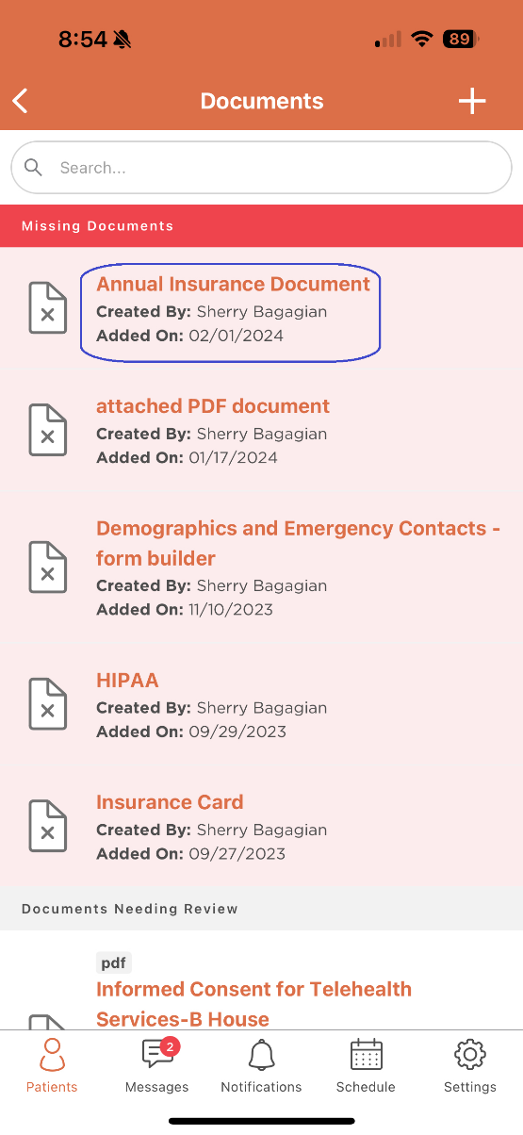

- Choose from the list of options to upload your document to Healthy Roster. The 'Scan Document With Camera' will be the best option for taking an image of your document and uploading it to the athlete profile.
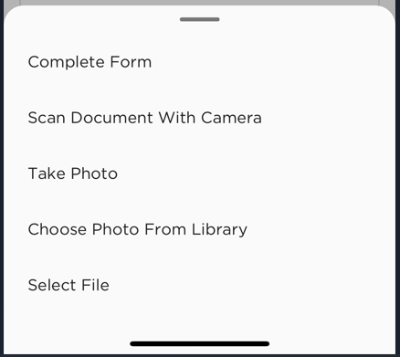
- Scan Document With Camera will launch your camera. If it's the first time using this feature, it will ask to allow permission to access your camera; you will want to Accept that. Frame the camera around the form that you're trying to scan and click on the shutter button circle at the bottom. You may take images of multiple pages when choosing this option.
- The completed images will appear in the bottom left hand corner - you'll then have the option to retake the image from this screen. Click Save when done scanning.
- The file will then upload and save to the patient profile. You'll know when it's done if the document is no longer in the Missing Documents section, or if you see the document listed in Uploaded Documents.

